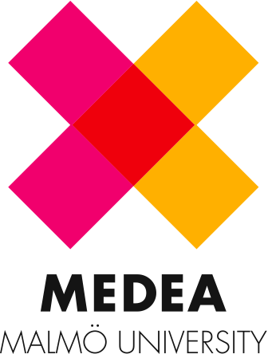
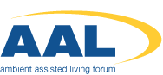
Submission Call
Idea-development Workshop & Hackathon at
the AAL Forum in Norrköping, Sweden, September 24th – 26.th, 2013.
-
Hands on – young researchers! Due to the success of the past workshops, we again would like to invite young scientists who investigate technical solutions for elderly for this year’s ‘Young researchers and PhD workshop’ at the AAL Forum in Norrköping 2013.

The workshop-format of 2013 has changed since the past years, meaning that the workshop has a huge focus on concept development, and prototyping of new technical solutions to support elderly users. Now you’ll get the change to have your subject or research transformed into a new service, a product, a tool or another innovation.

This year the young researchers workshop will explore how technology and social innovation can be used to support elderly in maintaining a meaningful occupation after their retirement, and to help elderly engage, communicate and develop new social contacts and networks. The workshop will approach the development from different aspects to explore – social innovation, intelligent products, services and tools.

The workshop format is inspired by the Hackathon-concept. This means that the workshop gets directed by a set of guidelines arranged by Medea*, a research centre for collaborative media at Malmö University.

The Workshop challenges your research:

- by idea-development in multi-disciplinary teams
- by methods of rapid prototyping and working with participatory design processes
- by a limited time of 36 hours with a set of constrains during the process
- by testing new ideas with end-users
- by getting a dialogue running with the conference delegates during the development process and on the end product.
- by showcasing the final concept for the conference delegates.

By these conditions one can expect to come up with new innovative solutions, which might have the potential of becoming business formats, a new research focus or contacts for future projects. The best three solutions get acknowledged by a prize at the closing event at the AAL conference.

The workshop is based on two tracks:

1) Young Researchers idea workshop: An idea-development workshop where participating researchers will work in multi-disciplinary teams that address the issues of supporting meaningful occupation for elderly.

2) Hackathon: A group of programmers will work on existing software in order to create new extensions on existing products and services. (Programmers are invited by a separate call)

Interactions between the tracks will be encouraged and facilitated.

Submission:

Young researchers invited are from academic disciplines including, but not limited to, geriatrics, engineering, architecture, informatics, psychology, sociology, nursing sciences, and economics.

Admission will be granted to those with bachelor’s degree up to PhDs and junior Postdocs.

Requirements for submission:
- Add a paper or a project-description 2-4 pages on a topic related to the headline ”Occupation of life”
- Write a short motivation for attending the idea-workshop (Max. 200 words).
- The application should be send to (both contacts):
anders.carlsson@newtoolsforhealth.com & eva.wendelboe.kuczynski@mah.se

For participants of this young researchers’ workshop the registration for the AAL Forum will be free.

Since the workshop will run during the conference, the program holds different intervals to join the conference program. Additional the participants gets a special preview on Vinnovas call 7, which will be published in November 2013.

Travel expenses and accommodation costs cannot be reimbursed from the Norrköping congress organisation.

For more information please visit the webpage here in the AAL Forum website.

*Facts box:
The workshop is facilitated by Medea, a research centre at Malmö University that hosts several labs where people from companies, organisations, public institutions and universities team up with citizens in order to experiment and create new products, services and new knowledge in real-life environments.
Link: http://medea.mah.se/

The workshop presents approaches by designers and researchers from:
Linköping University - Interaction & Service Design Research
Malmö University – Computer Science
Medea – Living Lab the Neighbourhood
Design University DK: Co-design Research Cluster

